# LAB-1

# UNDERSTANDING THE NETWORK EQUIPMENT

**THEORY:**

* **NETWORK EQUIPMENT**

Network devices (also called network devices) are devices or hardware used to connect computers and other devices so that they can communicate and share data in a network. Common Network Equipments are repeater, hub, switch, bridge, router, modem, network interface card, firewall, wap, void endpoint etc.

1. **Repeater:**

A [repeater](https://www.geeksforgeeks.org/repeaters-in-computer-network/) operates at the [physical layer](https://www.geeksforgeeks.org/physical-layer-in-osi-model/). Its main function is to amplify (i.e., regenerate) the signal over the same network before the signal becomes too weak or corrupted to extend the length to which the signal can be transmitted over the same network. When the signal becomes weak, they copy it bit by bit and regenerate it at its star topology connectors connecting following the original strength. It is a 2-port device.

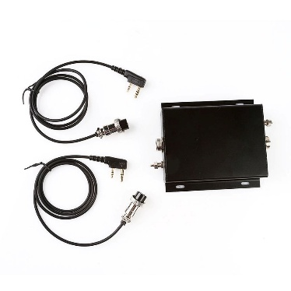

Fig: Repeater

1. **Hub:**

A [hub](https://www.geeksforgeeks.org/what-is-network-hub-and-how-it-works/) is a multiport repeater. A hub connects multiple wires coming from different branches, for example, the connector in [star topology](https://www.geeksforgeeks.org/advantages-and-disadvantages-of-star-topology/) which connects different stations. Hubs cannot filter data, so data packets are sent to all connected devices.  In other words, the collision domain of all hosts connected through Hub remains one.  Also, they do not have the intelligence to find out the best path for data packets which leads to inefficiencies and wastage.

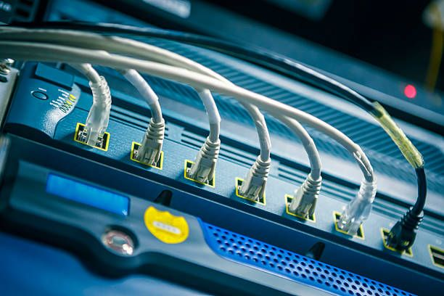

Fig: Hub

**Types of Hub:**

* **Active Hub**: These are the hubs that have their power supply and can clean, boost, and relay the signal along with the network. It serves both as a repeater as well as a wiring center. These are used to extend the maximum distance between nodes.
* **Passive Hub**: These are the hubs that collect wiring from nodes and power supply from the active hub. These hubs relay signals onto the network without cleaning and boosting them and can't be used to extend the distance between nodes.
* **Intelligent Hub**: It works like an active hub and includes remote management capabilities. They also provide flexible data rates to network devices. It also enables an administrator to monitor the traffic passing through the hub and to configure each port in the hub.

1. **Switch:**

A switch is a network device that is used to connect several computers or equipment within a single local area network (LAN) - such as in home, office or school. This helps the devices to talk efficiently to each other and share data.

Connects many devices A local area is included in computers, printers, servers, etc. within the network (LAN). Data forward to the right device Only the intended recipient sends data to the device (not for all devices). Uses Mac address to root data To know which device is on which port is a MAC address table to know. Network reduces traffic Unnecessary data broadcasting is avoided, making the network more efficient. Enables full-divine communication The equipment allows to send and receive data at the same time without a collision. Improves network speed and performance Ensures rapid communication by reducing conflict and data loss.

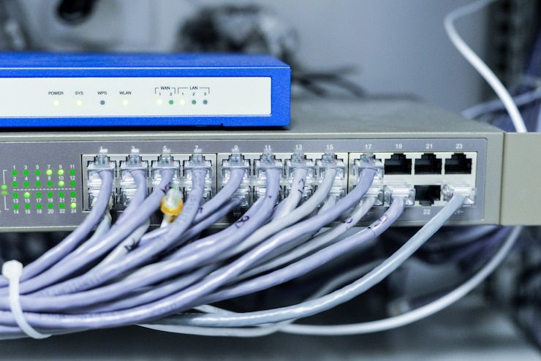

Fig: Switch

1. **Bridge:**

A [bridge](https://www.geeksforgeeks.org/difference-between-bridge-and-repeater/) operates at the data link layer. A bridge is a repeater, with add on the functionality of filtering content by reading the [MAC addresses](https://www.geeksforgeeks.org/mac-address-in-computer-network/) of the source and destination. It is also used for interconnecting two LANs working on the same protocol. It typically connects multiple network segments and each port is connected to different segment. A bridge is not strictly limited to two ports, it can have multiple ports to connect and manage multiple network segments. Modern multi-port bridges are often called Layer 2 switches because they perform similar functions.

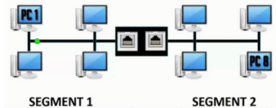

Fig: Bridge

**Types of Bridges**

* **Transparent Bridges:** These are the bridge in which the stations are completely unaware of the bridge's existence i.e. whether or not a bridge is added or deleted from the network, reconfiguration of the stations is unnecessary. These bridges make use of two processes i.e. bridge forwarding and bridge learning.
* **Source Routing Bridges:** In these bridges, routing operations is performed by the source station and the frame specifies which route to follow. The host can discover the frame by sending a special frame called the discovery frame, which spreads through the entire network using all possible paths to the destination.

1. **Router:**

A router is a tool like a switch that roots the data packet based on its IP address. The router is mainly a network layer device. Routers typically add LAN and WAN and are a dynamic updated routing table on the basis of which they decide on rooting the data packet. The router divides the broadcast domain of the host connected through it.

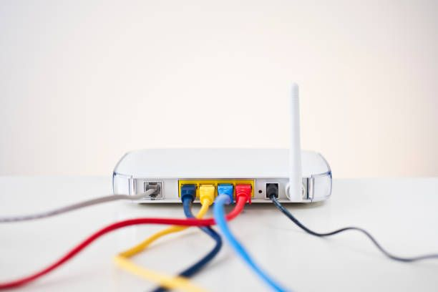

Fig: Router

1. **Modem:**

[Modem](https://www.geeksforgeeks.org/what-is-modem/) is also known as modulator/demodulator is a network device that is used to convert [digital signal](https://www.geeksforgeeks.org/advantages-and-disadvantages-of-digital-signals/) into [analog signals](https://www.geeksforgeeks.org/difference-between-analog-and-digital-signal/) of different frequencies and transmits these signals to a modem at the receiving location. These converted signals can be transmitted over the cable systems, telephone lines, and other communication mediums. A modem is also used to convert an analog signal back into digital signal. Modems are generally used to access the internet by customers of an [Internet Service Provider (ISP)](https://www.geeksforgeeks.org/isp-full-form/).

Fig: Modems

**Types of Modems**

There are four main types of modems:

* **DSL Modem:** Uses regular phone lines to connect to the internet but it is slower compared to other types.
* Cable Modem: Sends data through TV cables, providing faster internet than [DSL](https://www.geeksforgeeks.org/digital-subscriber-line-dsl/).
* **Wireless Modem:** Connects devices to the internet using [Wi-Fi](https://www.geeksforgeeks.org/what-is-wi-fiwireless-fidelity/) relying on nearby Wi-Fi signals.
* **Cellular Modem:** Connects to the internet using mobile data from a cellular network not Wi-Fi or fixed cables.

1. **Network interface card:**

A network interface card (NIC) is a hardware component that allows a computer or device to be connected to the network - either wired or wireless. It is like a gate that allows your device to talk to other devices on the Internet or local network.

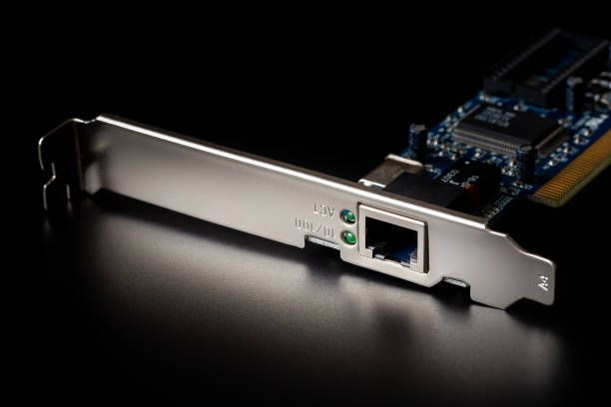

Fig: NIC

**NIC types:**

**1**. **Wired Nick (Ethernet Card)** :Uses a cable (lan cable) to connect to a network. Mango in desktop and server.

**2**. **Wireless NIC (Wi-Fi card):** Using Wi-Fi, connects to the network without wires.

1. **Firewall:**

A firewall is a network safety device that monitors and controls the flow of data between your computer or network and the Internet. It acts as a barrier, which allows unauthorized access to pass reliable data. Firewalls help protect your network from hackers, viruses and other online hazards by filtering traffic based on safety rules. Firewall physical equipment (hardware), programs (software), or even cloud-based services can occur, which can be offered as mother-in-law through public clouds or private virtual clouds.

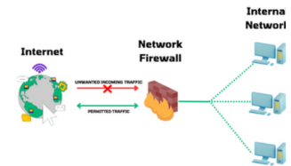

Fig: Firewall

1. **WAP:**

WAP is for wireless access points. It is a network device that allows a wireless device such as laptops, smartphones or tablets to connect to the wired network using Wi-Fi. Simple example: Imagine that you have an office with the Internet through a cable. If you want to use Wi-Fi on your phone or laptop, you connect a vap-it converts wired internet into wireless signals.

Fig: WAP

1. **Voip endpoint:**

Voice over Internet Protocol This means making phone calls on the Internet instead of traditional phone lines. A VoIP andpoint is any device or software that can send or receive voice calls on the Internet. Think of it as an early or termination point of a VoIP call - such as your phone or app that speaks on the network. Simple example: If you use Wi-Fi-SAPIPANS to call via Skype, that phone is working as VoIP andpoint.



Fig: Voip

**Conclusion:**

Understanding and implementing these networking devices leads to safe, smooth and efficient networks as a result of best practices, which operate your business. Network devices help to send and obtain data between various devices, allowing the device to be efficiently and safely connected to the network.